OS Lab 6

11762 Muhammad Kashif

Task 1

#!/bin/bash

echo "Hello world"

echo "Task 1"

echo "Please enter number 1"

read num

echo "Please enter number 2"

read num2

if [ $num -gt $num2 ]

then

num=$((num-num2))

num2=$((num+num2))

num=$((num2-num))

fi

while [ $num -ne $num2 ]

do

echo "printing number 1 $num"

num=$((num+1))

done

Output

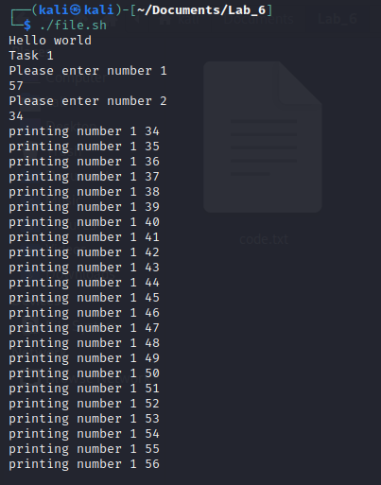

Task 2

Swipping

#!/bin/bash

echo "Hello world"

echo "Please enter number 1"

read num

echo "Please enter number 2"

read num2

echo "Swapping"

num=$((num-num2))

num2=$((num+num2))

num=$((num2-num))

echo "number 1"

echo $num

echo "number 2"

echo $num2

Output

